**Advance Excel Assignment 4**

1.To use the ribbon commands, what menu and grouping of commands will you find the Insert and Delete command?

Ans: Click on Home tab and then You will find Insert and Delete command in cell.

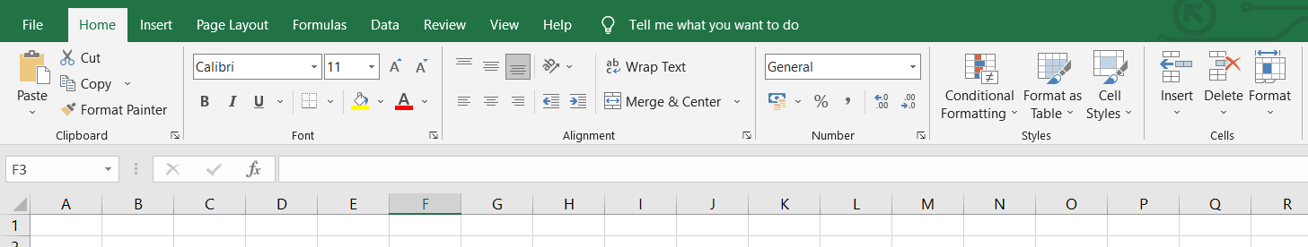

2. If you set a row height or column width to 0 (zero), what happens to the row and column?

Ans: If you set the row height to 0 (zero), Excel will hide the row.

3. Is there a need to change the height and width in a cell? Why?

Ans: It is necessary to change width and height in excel **to fit the data**. Excel by default provide equal width and height with respect to columns and rows. Whenever we enter a lengthy data, few characters will get displayed and other will be present inside the cell but will be hidden to the user.

4. What is the keyboard shortcut to unhide rows?

Ans: Press and hold down the Ctrl and the Shift keys on the keyboard.

5. How to hide rows containing blank cells?

Ans: 1. Select the range that contains empty cells you want to hide.

1. On the Home tab, in the Editing group, click Find & Select > Go To Special.
2. In the Go To Special dialog box, select the Blanks radio button, and click OK. ...
3. Press Ctrl + 9 to hide the corresponding rows.

6.What are the steps to hide the duplicate values using conditional formatting in excel?

Ans: On the Excel Ribbon, click the Home tab

* Click the Conditional Formatting command
* Click Manage Rules
* At the top of the Conditional Formatting Rules Manager, select "This Worksheet" from the drop down list

Each rule is listed, and shows its formula, format, range it applies to, and check box for "Stop if True.